Blockchain Trajectories in Graph Databases: A Neo4j-Based Model for Ethereum Transaction Analytics

Francisco Javier Moreno Arboleda
Juan Esteban Mejía Espejo
Georgia Garani
Abstract
Blockchain platforms generate large volumes of interconnected transactional data, whose analysis can reveal important patterns of account activity, value transfer, and user interaction. This paper proposes a graph database model for representing and analyzing Ethereum blockchain data. The proposed model captures blocks, accounts, external transactions, and internal transactions as graph nodes, while relationships represent temporal block succession, transaction recording, sender and receiver participation, and the decomposition of external transactions into internal transactions. By interpreting the blockchain as a trajectory of consecutive blocks, the model enables trajectory-style analytics over selected temporal windows. The model was implemented in Neo4j, using Ethereum data collected through the Etherscan API, and evaluated through Cypher queries over cumulative block ranges of 2, 10, 50, and 100 blocks. The queries analyze account activity, sender–receiver relationships, transaction volumes, and statistical properties of external and internal transactions. The experimental results show that the proposed graph representation can effectively identify highly active accounts, recurrent sender–receiver pairs, key intermediaries such as the Wrapped Ether contract, and stable behavioral patterns across different block ranges. The findings demonstrate the suitability of graph databases for blockchain transaction analysis and provide a foundation for future work on larger-scale blockchain analytics, anomaly detection, community discovery, and real-time graph-based monitoring.
Keywords: Blockchain analytics; Ethereum; Graph databases; Neo4j; Cypher queries; External transactions; Internal transactions; Transaction networks; Account activity; Blockchain trajectories

1. Introduction
Blockchain technology has revolutionized several sectors (Tschorsch & Scheuermann, 2016) due to its ability to provide a decentralized, immutable, and secure ledger for transactional data. Blockchain databases (DBs) usually store millions of transactions, e.g., as of late December 2025 bitcoin has more than 1.2 billion transactions and Ethereum more than 3.2 billion. This offers an opportunity to perform data analysis. The analysis of transactions in a blockchain platform helps us to understand the relationships and dynamics among their users (participants).
On the other hand, graph DBs (GDBs) stand out for their ability to manage graphs and query the relationships between their nodes. Unlike relational DBs (RDBs), which use relations (informally, tables) to store data, GDBs represent data as nodes and the relationships between them as edges (edges can also have data), facilitating the formulation of neighborhood queries, e.g., finding the nodes connected to a given node. This capability is well suited for modeling a blockchain DB, where blocks, transactions, and user accounts are interconnected, i.e., they form a network (a graph).
Thus, the convergence of blockchain and GDBs offers opportunities for analyzing blockchain data modeled as a graph. Representing a blockchain DB in a GDB not only enables visualization of the network’s structure, but also facilitates the formulation of queries to detect patterns, explore relationships between users, and, in general, gain valuable insights about the users’ behavior in a blockchain platform.
However, blockchain data analysis using graph databases (GDBs) remains relatively underexplored (see Section 2). The few existing studies in this direction, such as Estupiñan (2020) and Lin et al. (2020), mainly address topics such as address clustering, performance evaluation, and link prediction. The main contribution of this study lies in the analysis of the Ethereum network using graph queries to identify patterns and relationships among user accounts, thereby providing a deeper understanding of how users interact within the platform. Furthermore, the study introduces a formal graph model for the Ethereum blockchain and extends prior work (Estupiñan, 2020; Lin et al., 2020) by examining the composition and interrelation of external and internal transactions.
For the representation of a blockchain DB in a GDB, this work adopts a trajectory-based graph perspective. Α blockchain can naturally be modeled as a trajectory, namely as an ordered sequence of transactions anchored to a temporal backbone formed by the sequence of blocks, where each block contains a set of transactions. Under this representation, nodes correspond to blocks, transactions, and user accounts, while the edges represent i) the temporal succession of blocks, ii) the participation of user accounts as senders or receivers in transactions, which are themselves associated with blocks, and iii) the decomposition of external transactions into subtransactions (i.e., internal transactions). This perspective enables trajectory-style analytics, such as the analysis of sender–receiver behavior over a specific time interval. Therefore, the proposed approach goes beyond the mere visualization of the transaction network by providing a queryable graph-based representation of blockchain activity.

The trajectory-based perspective adopted in this work differs from a conventional temporal graph representation. In a standard temporal graph, transactions are typically modeled as timestamped edges between accounts, and time is treated mainly as an attribute of each interaction. In contrast, the proposed model uses the ordered sequence of blocks as the primary temporal backbone of the graph. Each block acts as a trajectory point that anchors a set of external transactions, while external transactions may further generate internal transactions. This structure allows blockchain activity to be analyzed over consecutive block windows rather than only through isolated timestamped interactions. As a result, the model supports trajectory-style analytical queries, such as identifying persistent active accounts, recurrent sender–receiver pairs, stable intermediaries, and changes in transaction behavior across cumulative block ranges. Therefore, the contribution is not limited to representing Ethereum as a graph, but consists in organizing blockchain activity as a queryable block trajectory that preserves the temporal, transactional, and hierarchical structure of Ethereum data.
The remainder of the paper is organized as follows. Section 2 reviews related works, focusing on trajectory modeling and blockchain analysis using GDBs. Building on this background, Section 3 introduces the proposed model and defines the specific nodes and relationships designed to represent the Ethereum components as trajectories. Subsequently, Section 4 presents the experimental setup and discusses the results obtained from executing analytical queries on different sets of blocks. Finally, Section 5 concludes the paper and outlines directions for future research.

2. Related works
This section reviews existing studies on trajectory modeling and blockchain analysis based on graph databases.
2.1. Trajectory modeling with GDBs
In Bakkal et al. (2017) trajectories are modeled and implemented in Neo4j to build a ridesharing (car-pooling) system. Two libraries are used: i) Spatial Library (Neo4j Spatial, 2017) for spatial querying and indexing and ii) GraphAware Neo4j TimeTree (GraphAware TimeTree, 2017) to represent time with second-level precision. A trajectory is represented by a set of nodes. A node may represent: i) a user, ii) a moment in time, expressed as a timestamp, iii) a position, defined by latitude and longitude, and iv) a link that connects the three preceding node types. In this sense, a link node indicates that a specific user is located at a given position at a particular moment in time. Therefore, each link node can be regarded as a point within a trajectory. The system operates as follows: a user (a hitchhiker) U requests a vehicle to reach a destination (a target). Three filters are applied to match users for ridesharing: i) the day of the week, ii) the identification of driver trajectories located within 100 m of U and within one hour of the request time, and iii) the identification of users whose recorded time is later than U’s request time and who are located within 100 m of the target destination. Experiments conducted on the Geolife dataset (Microsoft Research Asia, 2007), involving 182 users and 18,000 trajectories, demonstrate the feasibility of the system. However, the results are not further analyzed or discussed in terms of broader conclusions. As future work, the authors propose extending the system by incorporating user profiles based on demographic and social data.

Unlike previous works on trajectory modeling, Khan et al. (2017) focus on graph-based data management. They present a comparative performance analysis between a RDB management system (RDBMS) (Oracle 11g Enterprise Edition) and a GDB management system (GDBMS) (Neo4j 3.03 Community Edition), focusing on handling large datasets in the healthcare domain. Their evaluation considers several queries which, in Oracle, involve one or two joins and two or three correlated subqueries. The results show that Neo4j outperformed Oracle, with the performance gap widening as the dataset size increased. Neo4j’s advantage stems from its native handling of relationships, whereas Oracle relies on join operations to establish relationships between data elements. However, the authors note that further work is needed to assess other potential Oracle optimizations, such as implementing clusters of tables, pointers (REFs), or using operators like WITH and CONNECT BY, along with advanced indexing and partitioned tables. In addition, RDBMSs such as Oracle have been central to structured data management but face limitations due to their rigid schema. By contrast, GDBs such as Neo4j are particularly effective for managing unstructured or semi-structured data, due to the flexibility of their schema design.

In Gómez, Kuijpers, & Vaisman (2019) semantic trajectories (STs) are modeled as a graph, implemented in Neo4j, and their performance is compared with a relational implementation in PostgreSQL. A ST can be defined as a sequence of points of interest (POIs) visited by a moving object within a specific time period, thereby forming a graph of visited POIs. For example, a ST may represent that an object visited a Thai restaurant between 3 p.m. and 4 p.m., followed by a train station between 8 p.m. and 8:30 p.m. To support analytical querying, aggregation hierarchies are defined for both the POI and temporal dimensions. Within the POI hierarchy, a Thai restaurant may be classified as a restaurant, while a restaurant may, in turn, be classified as a meeting place. Similarly, within the temporal hierarchy, minutes may be aggregated into hours, days, or months. Based on these hierarchies, several analytical queries can be formulated such as: i) identifying trajectories that move from a home to a train station without intermediate stops, ii) identifying trajectories that pass within less than 500 m of a given POI, and iii) determining, for each trajectory, the paths that move from a home to an airport in the same day. The authors conclude that, overall, GDB queries execute between 1.2 and 7 times faster than their relational counterparts. The only exception concerns transitive-closure queries, that is, queries requiring the computation of all nodes reachable from a given starting node, such as query iii, which performed better in the relational implementation. For this type of query, the authors suggest that a graph-based implementation exploiting parallelism could improve performance.

Tamilmani & Stefanakis (2019) present an approach for modelling and analyzing Semantically Enriched Simplified Trajectories (SESTs) using GDBs. To simplify a trajectory, the SED (Synchronous Euclidean Distance) criterion (Meratnia & De By, 2004) and the SELF (Semantically Enriched Line SimpliFication) structure (Stefanakis, 2015) are applied, both of which preserve the original semantics of the trajectory. This simplification is necessary due to the huge number of GDB nodes (e.g., a moving object that generates one point per second produces 3,600 points in one hour). The resulting SESTs are stored and analyzed in Neo4j. The authors focus mainly on two types of queries: i) identifying the shortest and longest trajectories, considering both time and travelled distance, and ii) detecting collision regions within a given time interval TI. In the latter case, for each node, the number of neighboring nodes located within a specific distance and having timestamps within TI is computed, and the nodes with the maximum number of neighbors are selected. A basic tool for visualizing trajectories is also presented. As future work, the authors propose evaluating the complexity of the simplification algorithm and formulating additional queries that further exploit the semantic data in the SELF structure.

Karim et al. (2021) proposes a framework for collecting, storing, and analyzing pedestrian trajectories. Their approach uses PostGIS for storing spatial data and Neo4j with spatial APIs to model trajectories and identify nearby POIs. A UML class diagram is used to represent concepts such as i) trajectory events: Begin, Stop, and End, where a POI is considered a Stop when a pedestrian remains there beyond a predefined time threshold), ii) trajectory intent: commuting to work, returning home, shopping, etc., and iii) activity performed during the trajectory: eating during a stop, reading while travelling between stops, etc. However, the authors do not provide details on how trajectories are implemented in Neo4j, nor do they present analytical queries or experimental results. However, they conclude that the proposed architecture could contribute to road safety by detecting pedestrian risks.

Xue et al. (2022) propose CoGAT, a graph-based model for representing, storing, and analyzing Argo float trajectories. Argo floats are automated instruments that collect oceanographic data while moving vertically between the ocean surface and deeper water layers. The proposed framework uses Neo4j to store trajectory data in a GDB and Neo4j’s spatial API to implement trajectory structures and support pattern-finding queries.
The UML class diagram for modelling Argo float trajectories introduces several key concepts: i) TrajNode node, which represents the complete trajectory of an Argo float, ii) ParkingTrajNode and SurfaceTrajNode, which model trajectory segments at a specific depth and at the ocean surface, respectively, enabling the analysis of current influence at different depth levels, and iii) Subtrajectory, which represents a trajectory segment occurring either at a specific depth or at the surface during a single operational cycle of the float. CoGAT is evaluated against OSATDB, an Oracle Spatial–based Argo Trajectory DB proposed by Xue, Cunjin et al. (2021), which follows a conventional relational approach. The authors conclude that CoGAT achieves higher computational efficiency than OSATDB for the supported trajectory analysis tasks.
Elayam et al. (2022) introduces a hierarchical graph-based model for representing and analyzing mobility data. The model is evaluated using historical records from the European maritime network and is designed to identify movement patterns across multiple spatial and temporal granularities. The proposed framework combines MovingPandas and Python for preprocessing and trajectory handling, Uber H3 for spatial indexing, and Neo4j for graph storage, trajectory representation, and analytical querying. The model adopts a hierarchical graph structure that enables analysis at three abstraction levels: micro, meso, and macro. Spatial partitioning is based on hexagonal H3 grids, simplifying nearest-neighbor searches and supports six-direction movement analysis. Temporal partitioning defined in hours, days, weeks, or months, allows analysts to construct and examine graphs at different time granularities. The study demonstrates the usefulness of the model by identifying, among other findings, differences in traffic flows between specific port origins and destinations. As future work, the authors propose enriching the model with environmental and contextual data to support more comprehensive mobility analysis.
2.1. Blockchain analysis with GDBs
Estupiñán (2020) analyses Ethereum-blockchain modelling, loading, and querying with Neo4j, JanusGraph and DSE Graph. The study focuses on address clustering analysis which aims to associate multiple blockchain accounts with a single entity. Two Ethereum address clustering use cases are examined, both originally defined by Victor (2019): i) airdrop multi-participation, where a blockchain application sends free tokens to digital wallets and ii) deposit address re-use, where several wallets are connected through a common deposit address. For these use cases, the author proposes two graph models implemented in three GDBMS: one in which transactions are represented as nodes and another in which transactions are represented as edges. The experimental results show that Neo4j and DSE Graph achieve their maximum performance with the transaction-as-node model, whereas JanusGraph performs better with the transaction-as-edge model. The study further concludes that indexing capabilities play a decisive role in overall query performance.
Lin et al. (2020) model Ethereum transaction records as a temporal weighted multidigraph (TWMDG), in which each edge represents a transaction characterized by its amount, direction, and timestamp. The authors introduce new temporal random-walk strategies designed to capture time-dependent transaction flows and to improve the identification of dynamic, multi-dimensional relationships between accounts. The proposed methods are evaluated on real Ethereum data through a link-prediction task. The experimental results show that the temporal random-walk approaches outperform traditional random-walk techniques. As future work, the authors suggest extending the framework to other types of large-scale networks.
Table 1 summarizes the analyzed works.
Table 1. Summary of the analyzed works.
Reference | Contribution | Limitation
Bakkal et al. (2017) | Model and implement trajectories in Neo4j to support car-pool matching. | No performance metrics; modest dataset;  Trip semantics (cost, goal, purpose) not considered.
Khan et al. (2017) | Provide an empirical performance comparison between Neo4j and Oracle. | Spatial and spatio-temporal queries not considered.
Gómez, Kuijpers & Vaisman (2019) | Implement a semantic trajectory model in Neo4j and compare it against PostgreSQL. | Limited relational baseline; moderate  dataset; no big-data stress test.
Tamilmani & Stefanakis (2019) | Propose a method for modelling and analyzing SESTs in Neo4j. | Limited query evaluation; no large-scale benchmark;  algorithmic complexity not analyzed.
Estupiñán (2020) | Conducts clustering analysis on Ethereum. | Focused on clustering and performance for two Ethereum use cases.
Lin et al. (2020) | Propose a temporal weighted multidigraph (TWMDG) model for Ethereum transactions and introduces temporal random walk strategies for link prediction. | Focused on link prediction rather than transaction analysis; s  calability not addressed.
Karim et al. (2021) | Define a semantic trajectory model with events for pedestrian mobility analytics. | Neo4j schema and analytical queries not provided;  no experimental evaluation.
Xue et al. (2022) | Present CoGAT, a hierarchical graph model for representing Argo float trajectories in Neo4j. | Domain-specific to Argo floats; limited generic attributes; coarse  temporal granularity.
Elayam et al. (2022) | Propose a hierarchical graph-based model for analyzing mobility data at multiple spatial scales in Neo4j. | Validated only on maritime traffic data.

Most previous works are trajectory-centric, focusing primarily on spatial or temporal features of trajectories, performance comparisons in Neo4j and semantic simplification, rather than on blockchain analytics in a GDB. Although Ethereum has been modeled as a TWMDG mainly for link prediction purposes (Lin et al., 2020), and Ethereum graph representations have also been used to study indexing strategies and query performance for address clustering analysis (Estupiñán, 2020), limited attention has been given to formal graph-based models that support broader analytical processing of blockchain data.

The proposed contribution addresses this gap by proposing a formal model that enables graph-style analytical queries over Ethereum data. For example, the model can be used to identify the top ten sender-receiver pairs with the highest number of transactions across a sequence of consecutive blocks, i.e., across a trajectory of blocks. Moreover, the model and part of the analysis consider both external and internal transactions, an aspect that is not usually detailed in related works. By explicitly modelling the relationships among user accounts, blocks, and transactions, the proposed approach represents Ethereum data as a graph, and establishes it as a first-class source for analytics in a GDB.
Unlike previous Ethereum graph models that mainly represent transactions as temporal edges between accounts, the proposed model explicitly treats the sequence of blocks as a trajectory backbone and uses this structure to analyze account behavior over consecutive block windows.

3. Model definition
The proposed model is designed around the notion of a blockchain trajectory. In this context, a trajectory is not a spatial path, but an ordered sequence of consecutive blocks that defines the temporal progression of blockchain activity. Each block represents a trajectory point, and the transactions recorded in that block represent the activity associated with that point. This interpretation enables the analysis of Ethereum behavior over block windows, such as 2, 10, 50, or 100 consecutive blocks, while preserving the relationships among blocks, accounts, external transactions, and internal transactions.
Ethereum is a blockchain platform that, through its native cryptocurrency ether (ETH), supports the creation and execution of transactions and smart contracts. Ethereum transactions can be distinguished into two main types. An external transaction is a user-initiated action submitted by an externally owned account (EOA). It is recorded directly in a block and is uniquely identified by a transaction hash. An internal transaction, by contrast, is a value transfer or contract call triggered during the execution of an external transaction through smart-contract code. It is identified by its parent external transaction together with a sequential number.
Thus, an external transaction initiated by an EOA, whether addressed to another EOA or to a smart contract, may trigger a cascade of internal transactions across the Ethereum network, as illustrated in Figure 1.



External transaction
Internal transactions
Smart contract
EOA
(Sender)

Receiver (EOA or Smart contract)




Figure 1. External and internal transactions.

3.1 Block node
A block is a collection of validated transactions. It contains metadata such as the block number, the parent hash which links it to the previous block, the creation date, and other related information.
In the proposed model, a block is represented by two main attributes: i) blockNumber, also known as the block height, which uniquely identifies a block and corresponds to its position in the blockchain; and ii) dateCreation, which denotes the date and time at which the block is created.
The following constraints are considered: i) blockNumber is a consecutive natural number starting from one; and ii) for any two distinct blocks b₁ and b₂, b₁ ≠ b₂, with blockNumbers bn₁ and bn₂, if bn₁ < bn₂, then the dateCreation of b₂ is later than the dateCreation of b₁.
Therefore, the block node datatype is defined as a tuple NblockDt = (blockNumber, dateCreation), where blockNumber ∈ ℕ and dateCreation ∈ Timestamp.

3.2 Transaction node
A transaction is a signed message that either transfers ETH or invokes smart-contract code.
The following attributes are considered for a transaction: i) transactionHash, which is the unique identifier of an external transaction, represented as a hash number; for internal transactions, this attribute is empty, ii) isInternalTransaction, a Boolean attribute indicating whether a transaction is internal (True) or external (False), iii) value, which denotes the amount of ETH transferred by the transaction, iv) sequenceId, which, for internal transactions, is a consecutive natural number starting from one and is used to distinguish multiple internal transactions generated by the same external or parent transaction; for external transactions, this field is empty, and v) parentTransactionHash, which, for internal transactions, stores the hash of the external transaction that generated them, while for external transactions this field is empty.

A transaction node datatype is a tuple NtransactionDt = (transactionHash, isInternalTransaction, value, sequenceId, parentTransactionHash), where transactionHash ∈ Hash number, isInternalTransaction ∈ Boolean, value ∈ ℝ⁺, sequenceId ∈ ℕ, and parentTransactionHash ∈ Hash number.
3.3 Account node
An account is an entity identified by an Ethereum address. It can hold ETH and, in the case of a smart contract, may also contain executable code. Ethereum defines two types of accounts: Externally Owned Accounts (EOAs), which are controlled by users, and smart contract accounts, which are controlled by deployed code.
The following attributes are considered for an account: i) address, which is the unique identifier of the account and is represented as a hash number, ii) balance, which denotes the current balance of ETH held by the account, and iii) isContract, a boolean attribute indicating whether the account is a smart contract (True) or an EOA (False).
An account node datatype is a tuple NaccountDt = (address, balance, isContract), where address ∈ Hash number, balance ∈ ℝ⁺, and isContract ∈ Boolean.
3.4 Edges
Several types of edges are considered.
3.4.1 Previous block edge
A previous block edge represents the link between a block and its immediate predecessor in the blockchain. The following attributes are considered for a previous block edge: i) currentBlockNumber, which denotes the block number of the current block and ii) previousBlockNumber, which denotes the block number of the preceding block.
The following constraint is also considered: currentBlockNumber must be equal to previousBlockNumber + 1 ensuring that the edge connects two consecutive blocks.

A previous block edge datatype is a tuple EpreviousBlockDt = (currentBlockNumber , previousBlockNumber), where currentBlockNumber ∈ ℕ, and previousBlockNumber ∈ ℕ.
3.4.2 Recorded in edge
A recorded in edge connects an external transaction to the block in which it is recorded. The following attributes are considered for a recorded in edge: i) containerBlockNumber, which denotes the block number of the block that contains the transaction and ii) transactionHash, which denotes the hash number of the external transaction.
The following constraints are also considered: i) containerBlockNumber and transactionHash must reference a valid block and a valid transaction in the Ethereum blockchain, respectively, ii) each transaction must be recorded in exactly one block, whereas a block may contain multiple transactions, and iii) the transaction referenced by transactionHash must have the value False in the isInternalTransaction attribute since only external transactions are recorded directly in blocks.

A recorded in edge datatype is a tuple ErecordedInDt = (containerBlockNumber, transactionHash), where containerBlockNumber ∈ ℕ, and transactionHash ∈ Hash number.
3.4.3 Sent by and received by edges
Both sent by and received by edges connect an external transaction to an account that participates in it. The distinction between the two edge types lies in the role of the account in the transaction, either as a sender or as a receiver. For both edge types, the following attributes are considered: i) transactionHash, which denotes the hash value of the external transaction and ii) accountAddress, which denotes the address of the participating account.
The following constraints are also considered: i) transactionHash must reference a valid external transaction in the Ethereum blockchain, for which the isInternalTransaction attribute has the value False, ii) accountAddress must reference a valid Ethereum account, iii) each external transaction must be associated with exactly one sender and one receiver, whereas each sender or receiver account may participate in multiple external transactions, and iv) for the same transaction, the senderAddress and receiverAddress must be different.

A sent by edge represents the relationship between an external transaction and its sending account. A sent by edge datatype is a tuple EsentByDt = (transactionHash, senderAddress), where transactionHash ∈ Hash number, and senderAddress ∈ Hash number.
A received by edge represents the relationship between an external transaction and its receiving account. A received by edge datatype is a tuple EreceivedByDt = (transactionHash, receiverAddress), where transactionHash ∈ Hash number, and receiverAddress ∈ Hash number.
Figure 2 presents a subgraph that highlights the relationships between blocks and external transactions. The diagram illustrates how a transaction node is anchored to the block node in which it is recorded through a recorded in edge. Furthermore, it depicts the interaction between transaction and account nodes, where the sent by and received by edges identify the sender and receiver accounts, respectively. Finally, the chronological chain is represented by the previous block edge, which connects each block to its immediate predecessor.

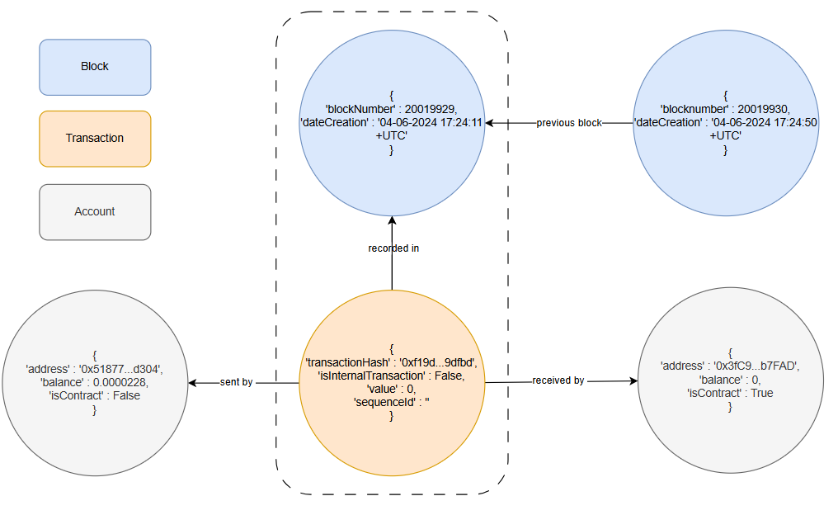
Figure 2. Structure of blocks and external transactions.
3.4.4 Internal transaction edge
An internal-transaction edge represents an internal transaction generated by an external transaction. The following attributes are considered for an internal-transaction edge: i) parentTransactionHash, which denotes the hash number of the external transaction that generated the internal transaction, and ii) sequenceId, which is a consecutive natural number starting from 1 and is used to distinguish multiple internal transactions generated by the same external transaction.
The following constraint is also considered: the transaction referenced by parentTransactionHash must have the value False in the isInternalTransaction attribute, since it corresponds to an external transaction.

An internal transaction edge datatype is a tuple EinternalTransactionDt = (parentTransactionHash, sequenceId), where parentTransactionHash ∈ Hash number, and sequenceId ∈ ℕ.
3.4.5 Internal sent by and internal received by edges
Both internal sent by and internal received by edges connect an internal transaction to an account that participates in it. The distinction between the two edge types lies in the role of the account, either as a sender or as a receiver. For both edge types, the following attributes are considered: i) parentTransactionHash, which denotes the hash value of the parent external transaction that generated the internal transaction, ii) sequenceId, which is a consecutive natural number starting from 1 that uniquely identifies the internal transaction among those generated by the same parent transaction, and iii) accountAddress, which denotes the address of the account participating in the internal transaction.

The following constraints are also considered: i) the pair (parentTransactionHash, sequenceId) must reference a valid internal transaction, ii) accountAddress must reference a valid Ethereum account, and iii) each internal transaction must be associated with exactly one sender and exactly one receiver, whereas each sender or receiver account may participate in multiple internal transactions.

An internal sent by edge represents the relationship between an internal transaction and its sending account. An internal sent by edge datatype is a tuple EinternalSentByDt = (parentTransactionHash, sequenceId, senderAddress), where parentTransactionHash ∈ Hash number, sequenceId ∈ ℕ, and senderAddress ∈ Hash number.
An internal received by edge represents the relationship between an internal transaction and its receiving account. An internal received by edge datatype is a tuple EinternalReceivedByDt = (parentTransactionHash, sequenceId), senderAddress), where parentTransactionHash ∈ Hash number, sequenceId ∈ ℕ, and receiverAddress ∈ Hash number.
Figure 3 illustrates the hierarchical relationship between an external transaction and the internal transactions it generates. The diagram shows an external transaction node anchored to a block through a recorded in edge. This external transaction acts as a parent transaction and may generate multiple internal transaction nodes. These internal transaction nodes are linked to their parent through internal transaction edges and are uniquely identified by the combination of the parent transaction hash and a sequence identifier. Finally, the diagram represents the flow of funds or calls within these internal transactions by using internal sent by and internal received by edges to connect them with the corresponding account nodes.

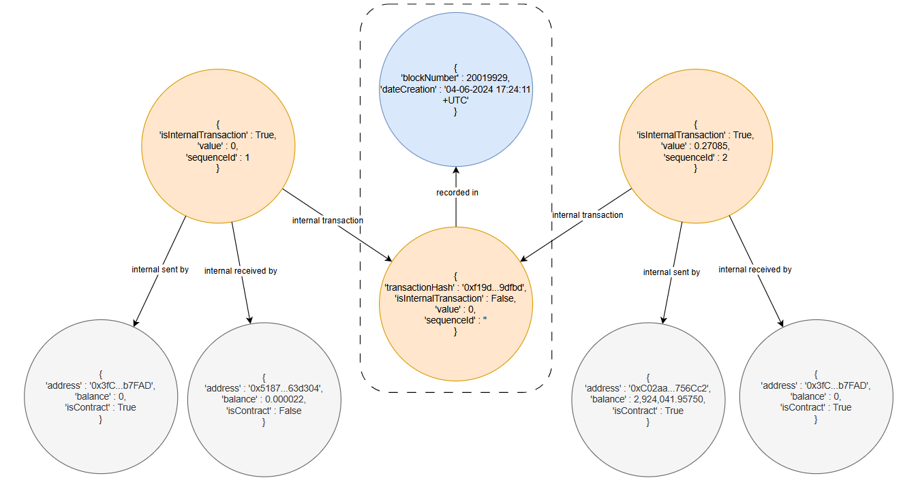
Figure 3. Relationship between external and internal transactions.

4. Experiments
To implement the proposed model, data were obtained from the Ethereum blockchain. For this purpose, a Python program was developed to extract data from a selected set of blocks using the Etherscan API, which provides access to Ethereum blockchain data and supports their exploration. The experiments were conducted on a MacBook Air equipped with an Apple M4 chip and 16 GB of RAM, running macOS Tahoe 26.3. The GDB was managed using Neo4j version 2026.01.3.

The data collection process comprised the following steps: i) requests were submitted through the Etherscan API to retrieve data related to account addresses, blocks, and transactions, ii) for each block, its block number, timestamp, and data concerning its external and internal transactions, were collected, iii) for each account address, its balance and type, namely user account or smart contract account, were retrieved, and iv) for each transaction, the containing block, transaction hash value, transaction type, namely external or internal, and the amount of ETH transferred, were obtained.

The collected data were structured into nodes and relationships, according to the proposed model, as illustrated in Figures 2 and 3, and were subsequently loaded into a Neo4j GDB. In this representation, nodes correspond to entities such as account addresses, blocks, and transactions. Relationships between nodes are established based on the model specification, including for example, the “sent by” and “received by” relationships that connect transactions to the participating accounts, as well as the links between consecutive blocks that capture the chronological structure of the blockchain.

The average time required to load one block into Neo4j was four minutes. A sequence of 100 consecutive blocks was loaded, starting from block number 20,512,878 (mined on Aug-12-2024 13:38:23 UTC). To analyze the network’s behavior across different temporal windows, the data were processed in cumulative batches of 2, 10, 50, and 100 blocks. For each batch, a series of queries was executed, as described in Sections 4.1-4.4, and the corresponding statistics were recorded. After the data had been loaded into the Neo4j GDB, the queries were executed and organized into four groups: i) account activity based on ETH transfers, ii) account activity based on the number of transactions, iii) relationships between accounts, and iv) general transaction statistics. In the reported results, highlighted items indicate elements that appear consistently across all tested block sizes. The complete results are provided in Appendix A.
Although the data ingestion process required approximately four minutes per block on average, this delay was mainly caused by external factors, such as rate limits with the Etherscan API. By contrast, the GDB performance was highly efficient: all Cypher queries were executed in less than one second, even for the dataset containing 100 blocks. However, since 100 blocks represent only a limited portion of the Ethereum blockchain, experiments with larger datasets are required to assess scalability more comprehensively. Therefore, the main bottleneck was the external data acquisition rather than query execution within the GDB.

4.1. Queries on account activity (ETH transfers)
The ten most active accounts in terms of ETH received or sent were identified.
4.1.1 Obtain the ten accounts that received most ETH.
MATCH (u:User)-[:RECEIVED_BY]->(tx)
WITH u.address AS account,
CASE
WHEN tx:ExternalTransaction THEN tx.value
WHEN tx:InternalTransaction THEN tx.amount
END AS received_amount
RETURN account, SUM(received_amount) AS total_received
ORDER BY total_received DESC
LIMIT 10
For external transactions, the amount of ETH received is stored in the tx.value attribute, whereas for internal transactions it is stored in the tx.amount attribute. Therefore, a CASE statement was used in the query to handle both transaction types. Table 2 presents the results obtained for two blocks. The same query was also executed for datasets containing 10, 50, and 100 blocks, and the corresponding results are reported in Appendix A.

Table 2. Results of Query 4.1.1 for two blocks.
Rank | Account | Total_received (ETH)
1 | 0x10da...56ba8e | 50,000
2 | 0xc02a...756cc2 | 15,220
3 | 0xe37e...57bd09 | 9,600
4 | 0x1111...960582 | 7,634
5 | 0x7a25...f2488d | 5,841
6 | 0x449f...a3d115 | 5,108
7 | 0x77f8...292702 | 2,970
8 | 0x3220...bf5daa | 2,804
9 | 0x3fc9...2b7fad | 2,782
10 | 0x1111...842a65 | 2,740
Figure 4 shows the ten accounts that received the highest total amount of ETH over 2, 10, 50, and 100 blocks.

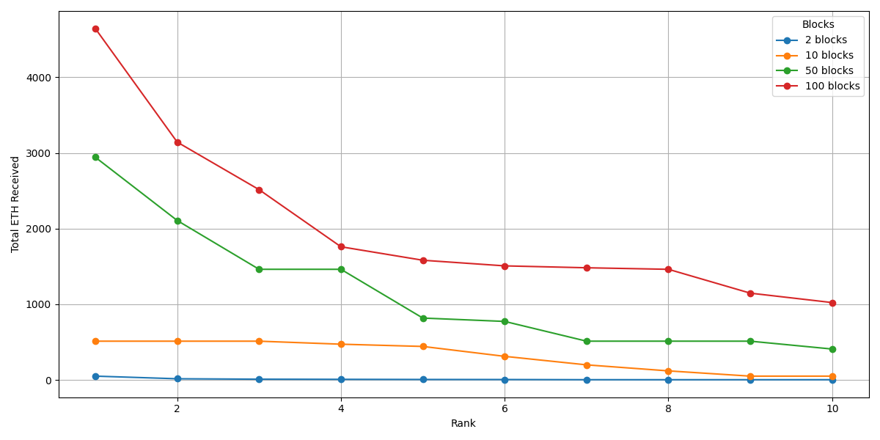
Figure 4. Total ten accounts by total ETH received across 2, 10, 50, and 100 blocks.

4.1.2 Obtain the ten accounts that sent most ETH.
MATCH (u:User)-[:SENT_BY]->(tx)
WITH u.address AS account,
CASE
WHEN tx:ExternalTransaction THEN tx.value
WHEN tx:InternalTransaction THEN tx.amount
END AS sent_amount
RETURN account, SUM(sent_amount) AS total_sent
ORDER BY total_sent DESC
LIMIT 10
Table 3 presents the results for two blocks. The corresponding results for 10, 50, and 100 blocks are provided in Appendix A.

Table 3. Results of Query 4.1.2 for two blocks.
Rank | Account | Total_sent (ETH)
1 | 0xc02a...756cc2 | 55,555
2 | 0xe37e...57bd09 | 9,600
3 | 0x1111...960582 | 7,634
4 | 0x7f1d...e4219b | 7,451
5 | 0x3a21...a74b22 | 5,108
6 | 0x7a25...f2488d | 3,641
7 | 0x6edf...1c5048 | 2,804
8 | 0x3fc9...2b7fad | 2,782
9 | 0x1111...842a65 | 2,740
10 | 0xea22...d676f5 | 2,300
Figure 5 shows the ten accounts that sent the highest total amount of ETH across 2, 10, 50, and 100 blocks.

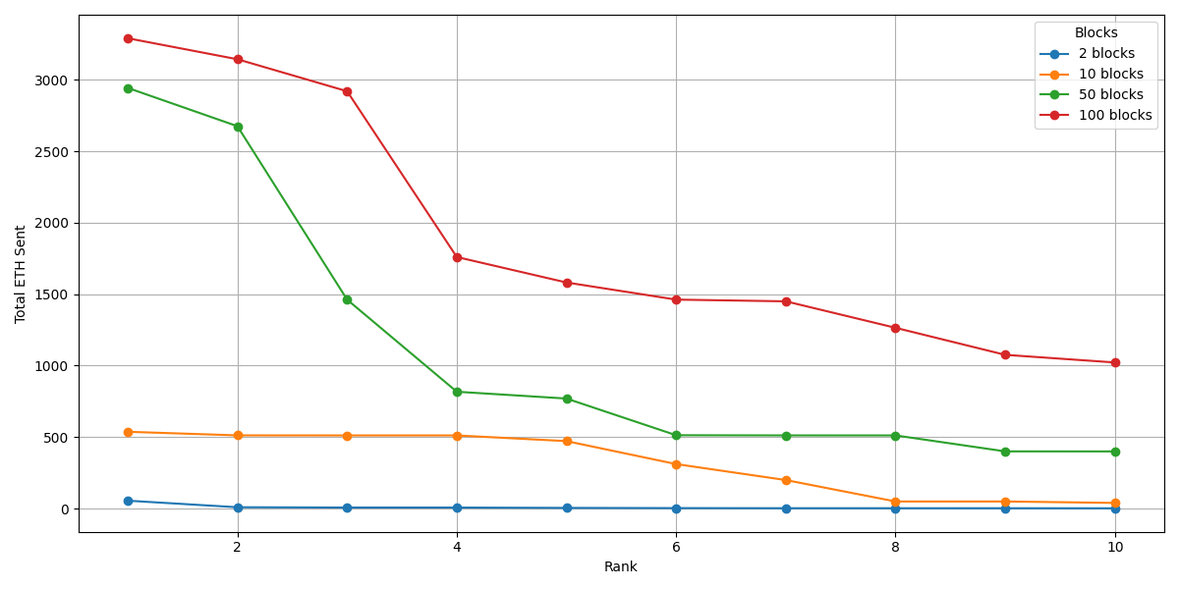
Figure 5. Total ETH sent by the top ten accounts across 2, 10, 50, and 100 blocks.

As shown in Figures 4 and 5, increasing the block range leads to higher total amounts of ETH received and sent by the most active accounts. Across the datasets containing 2, 10, 50, and 100 blocks, two accounts consistently appeared among the top ten, both as receivers and senders. One of these accounts corresponds to the Wrapped Ether token contract address (0xc02aaa39b223fe8d0a0e5c4f27ead9083c756cc2), which is a smart contract that implements the ERC-20 standard and is widely used to support interoperability with ERC-20–based decentralized applications. This finding highlights its role as a key intermediary in the observed transactions. The other account (0x111111125421ca6dc452d289314280a0f8842a65) does not appear to be an internal Ethereum contract, and is therefore likely associated with a network user (an EOA). These queries are useful for identifying the accounts that transfer the largest amounts of ETH within the network for each selected block range. Moreover, the results show that, in all experiments, namely for 2, 10, 50, and 100 blocks, the total amount of ETH sent by the top ten sending accounts exceeded the total amount of ETH received by the top ten receiving accounts.

4.2. Account Activity Statistics by Number of Transactions
Account activity is evaluated based on the percentage of transactions in which each account participates. The following queries identify the accounts with the highest percentages of received transactions, sent transactions, and overall transaction participation.

4. 2.1 Obtain the ten accounts with the highest percentage of transactions received.
MATCH (u:User)-[:RECEIVED_BY]->(tx)
WITH COUNT(tx) AS total_transactions
MATCH (u:User)-[:RECEIVED_BY]->(tx)
WITH u.address AS account, COUNT(tx) AS received_transactions, total_transactions
RETURN account,
(received_transactions / total_transactions) * 100 AS received_percentage
ORDER BY received_percentage DESC
LIMIT 10
Table 4 presents the results obtained for two blocks. The same query was also executed for datasets containing 10, 50, and 100 blocks, and the corresponding results are reported in Appendix A.

Table 4. Results of Query 4.2.1 for two blocks.
Rank | Account | Received_percentage (%)
1 | 0xdac1...831ec7 | 9,813
2 | 0xc02a...756cc2 | 8,645
3 | 0x3fc9...2b7fad | 4,907
4 | 0x7a25...f2488d | 3,972
5 | 0xa0b8...06eb48 | 2,804
6 | 0x80a6...cd5d9e | 2,336
7 | 0x1111...960582 | 2,103
8 | 0x69a4...152cea | 1,636
9 | 0x3328...309c49 | 1,636
10 | 0xa8f2...2acba4 | 1,401
Figure 6 presents the percentage of transactions received by the ten accounts with the highest number of received transactions across datasets containing 2, 10, 50, and 100 blocks.

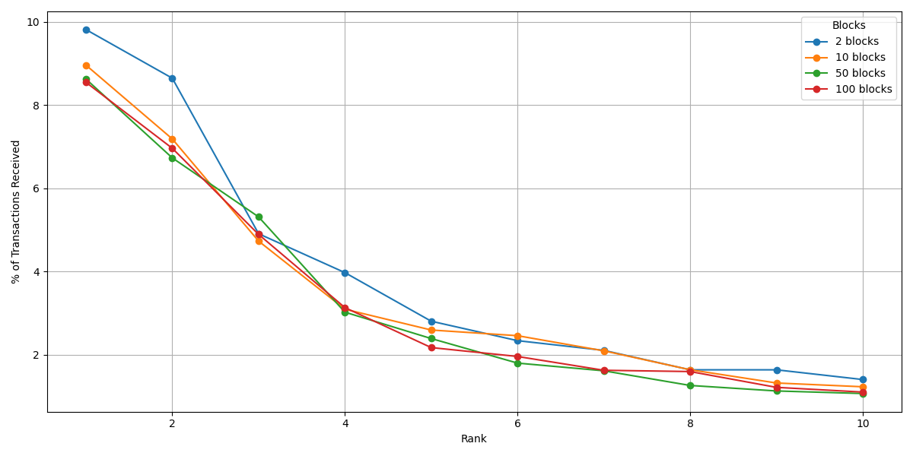
Figure 6. Top ten accounts by percentage of received transactions across 2, 10, 50, and 100 blocks.

The previous query traverses the graph twice, using two independent MATCH clauses. However, the graph can be traversed only once by using the following query:

MATCH (u:User)-[:RECEIVED_BY]->(tx)
WITH u.address AS account, COUNT(tx) AS received_transactions
WITH COLLECT({account: account, cnt: received_transactions}) AS rows,
SUM(received_transactions) AS total_transactions
UNWIND rows AS row
RETURN row.account AS account,
(row.cnt / total_transactions) * 100 AS received_percentage
ORDER BY received_percentage DESC
LIMIT 10

Using the optimized query, the results remained unchanged, while the execution time was reduced by approximately 50% compared with the previous query. However, both queries were executed in less than a second, even for the dataset containing 100 blocks. The same optimization can also be applied to Queries 4.2.2 and 4.2.3. Nevertheless, for simplicity, the non-optimized versions of the queries are presented.

4.2.2 Obtain the ten accounts with the highest percentage of transactions sent.
MATCH (u:User)-[:SENT_BY]->(tx)
WITH COUNT(tx) AS total_transactions
MATCH (u:User)-[:SENT_BY]->(tx)
WITH u.address AS account, COUNT(tx) AS sent_transactions, total_transactions
RETURN account,
(sent_transactions / total_transactions) * 100 AS sent_percentage
ORDER BY sent_percentage DESC
LIMIT 10
Table 5 presents the results obtained for two blocks. The same query was also executed for datasets containing 10, 50, and 100 blocks, and the corresponding results are reported in Appendix A.

Table 5. Results of Query 4.2.2 for two blocks.
Rank | Account | Sent_percentage (%)
1 | 0xc02a...756cc2 | 7,243
2 | 0x7a25...f2488d | 3,271
3 | 0x3fc9...2b7fad | 3,271
4 | 0xe37e...57bd09 | 2,336
5 | 0x1111...960582 | 1,402
6 | 0x80a6...cd5d9e | 1,402
7 | 0xdfd5...43963d | 1,168
8 | 0x0000...3eb395 | 1,168
9 | 0x3328...309c49 | 1,168
10 | 0x4634...eb9758 | 1,168
Figure 7 presents the percentage of transactions sent by the ten accounts with the highest number of sent transactions across datasets containing 2, 10, 50, and 100 blocks.

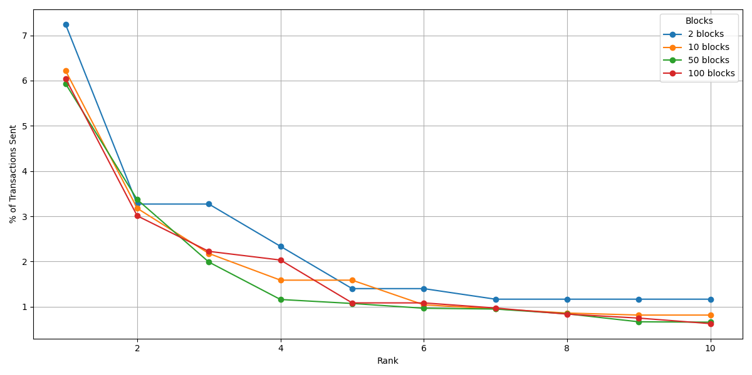
Figure 7. Top ten accounts by percentage of sent transactions across 2, 10, 50, and 100 blocks.
4.2.3 Identify the ten accounts with the highest overall transaction participation percentage, considering both sent and received transactions.
MATCH (tx)
WITH COUNT(tx) AS total_transactions
MATCH (u:User)
OPTIONAL MATCH (u)-[:SENT_BY]->(tx1)
OPTIONAL MATCH (u)-[:RECEIVED_BY]->(tx2)
WITH u.address AS account,
(COUNT(tx1) + COUNT(tx2)) AS sent_received_transactions, total_transactions
RETURN account,
(sent_received_transactions / total_transactions) * 100 AS total_percentage
ORDER BY total_percentage DESC
LIMIT 10
Table 6 presents the results obtained for two blocks. The same query was also executed for datasets containing 10, 50, and 100 blocks, and the corresponding results are reported in Appendix A.
Table 6. Results of Query 4.2.3 for two blocks.
Rank | Account | Total_percentage (%)
1 | 0xc02a...756cc2 | 7,944
2 | 0xdac1...831ec7 | 4,907
3 | 0x3fc9...2b7fad | 4,089
4 | 0x7a25...f2488d | 3,621
5 | 0x80a6...cd5d9e | 1,869
6 | 0xe37e...57bd09 | 1,869
7 | 0x1111...960582 | 1,752
8 | 0x3328...309c49 | 1,402
9 | 0xa0b8...06eb48 | 1,402
10 | 0x69a4...152cea | 1,168
Figure 8 presents the percentage of transactions associated with the ten accounts having the highest overall transaction participation, considering both received and sent transactions across datasets containing 2, 10, 50, and 100 blocks.
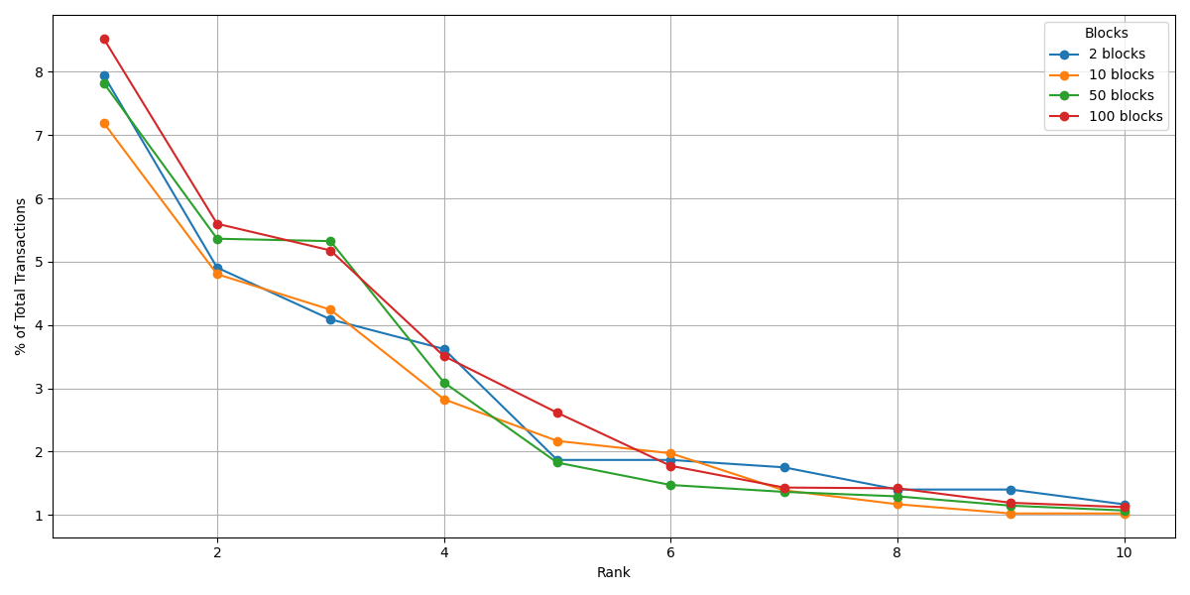
Figure 8. Top ten accounts by percentage of total transactions participation across 2, 10, 50, and 100 blocks.

Despite variations in the number of analyzed blocks, the participation percentages of the top ten accounts tended to remain relatively stable. For example, across datasets containing 2, 10, 50, and 100 blocks, the highest-ranked account represented approximately 8% to 10% of received transactions, 6% to 7.5% of sent transactions, and 7% to 8.5% of total transaction participation, considering both sent and received transactions. For each corresponding role, namely received, sent, or total participation, the same five accounts typically occupied the top five positions across all block ranges. This suggests the presence of highly active accounts in the network, at least within the blocks analyzed in these experiments, such as the Wrapped Ether account (0xc02aaa39b223fe8d0a0e5c4f27ead9083c756cc).

4.3. Relationships Between Accounts
This analysis identifies the most active account pairs, consisting of sender and receiver accounts, based on the number of transactions they share. The following queries determine the account pairs with the highest number of shared transactions, as well as the pairs that exchanged the largest amounts of ETH.
4.3.1 Identify the ten sender-receiver pairs with the highest number of external transactions.

MATCH (sender:User)-[:SENT_BY]->(tx:ExternalTransaction)<-[:RECEIVED_BY]-(receiver:User)
RETURN sender.address AS sender, receiver.address AS receiver,
COUNT(tx) AS total_transactions
ORDER BY total_transactions DESC
LIMIT 10
Table 7 presents the results obtained for two blocks. The same query was also executed with datasets containing 10, 50, and 100 blocks, and the corresponding results are reported in Appendix A.

Table 7. Results of Query 4.3.1 for two blocks.
Rank | Sender -> Receiver | Total_transactions
1 | 0xf89d...5eaa40 -> 0xdac1...831ec7 | 3
2 | 0xdfd5...43963d -> 0xdac1...831ec7 | 2
3 | 0xa85b...632108 -> 0x4c67...82f802 | 2
4 | 0x5433...cd3c08 -> 0xea22...d676f5 | 2
5 | 0x2326...7a5798 -> 0x3bc1...514326 | 2
6 | 0xb233...d7c460 -> 0xdac1...831ec7 | 2
7 | 0xcc3f...38e4e1 -> 0x5bf3...98a8ed | 2
8 | 0x4481...3f5af8 -> 0x68d3...e66fbf | 2
9 | 0x978d...efb7e7 -> 0xa5a7...07bdb6 | 2
10 | 0x89e5...aa7c40 -> 0xdac1...831ec7 | 2
Figure 9 presents the number of transactions associated with the ten sender–receiver pairs having the highest transaction counts across datasets containing 2, 10, 50, and 100 blocks.
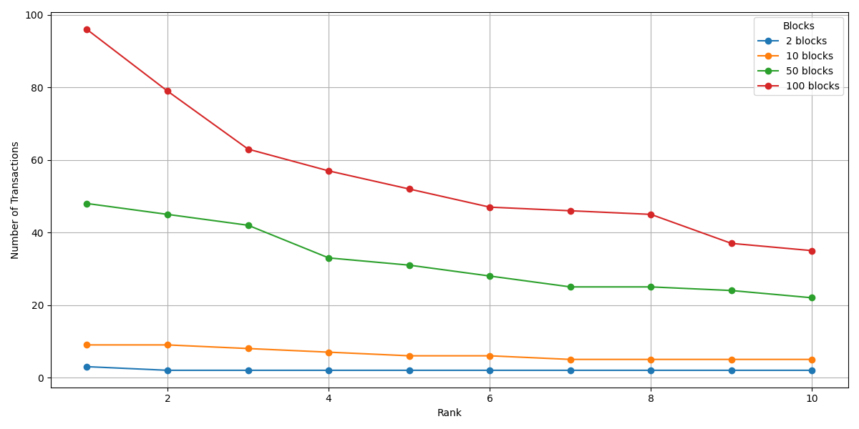
Figure 9. Top ten sender–receiver pairs by total number of external transactions across 2, 10, 50, and 100 blocks.

4.3.2 Identify the ten sender-receiver pairs with the highest total amount of ETH transferred between them.

MATCH (sender:User)-[:SENT_BY]->(tx:ExternalTransaction)<-[:RECEIVED_BY]-(receiver:User)
RETURN sender.address AS sender, receiver.address AS receiver,
SUM(tx.value) AS total_value_sent
ORDER BY total_value_sent DESC
LIMIT 10
Table 8 presents the results obtained for two blocks. The same query was also executed for datasets containing 10, 50, and 100 blocks, and the corresponding results are reported in Appendix A.
Table 8. Results of Query 4.3.2 for two blocks.
Rank | Sender -> Receiver | Total_value_sent (ETH)
1 | 0x7f1d...e4219b -> 0x1111...960582 | 7,451
2 | 0x3a21...a74b22 -> 0x449f...a3d115 | 5,108
3 | 0x6edf...1c5048 -> 0x3220...bf5daa | 2,804
4 | 0x5433...cd3c08 -> 0xea22...d676f5 | 2,300
5 | 0x34e1...3b2093 -> 0x1111...842a65 | 2,000
6 | 0x1fa9...37b4b7 -> 0x2ea1...4b1281 | 1,493
7 | 0x5f0b...4bac7b -> 0x80a6...cd5d9e | 1,000
8 | 0x978d...efb7e7 -> 0xa5a7...07bdb6 | 0,967
9 | 0x1a2d...691f13 -> 0x3fc9...2b7fad | 0,660
10 | 0xf855...288101 -> 0x3fc9...2b7fad | 0,614
Figure 10 presents the total amount of ETH transferred by the ten sender–receiver pairs with the highest total ETH transfers across datasets containing 2, 10, 50, and 100 blocks.
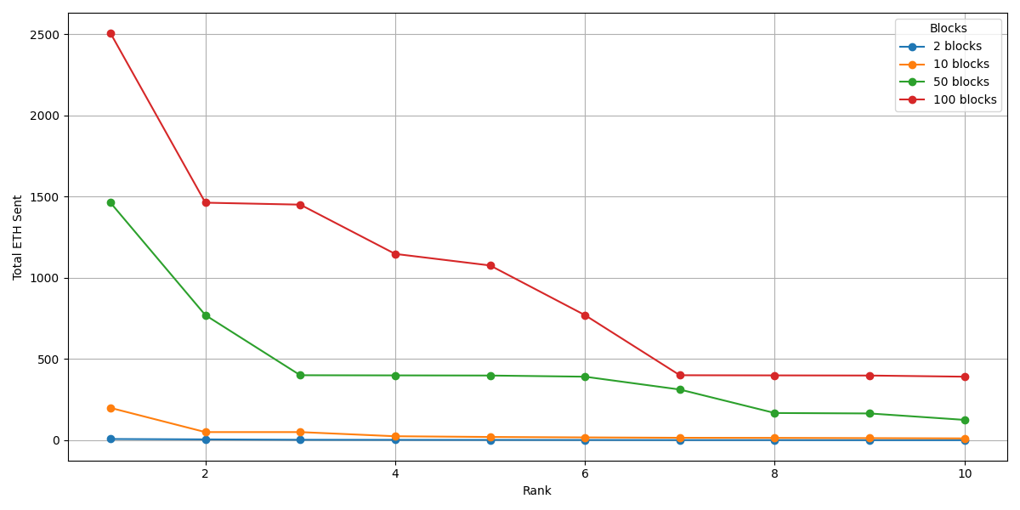
Figure 10. Top ten sender–receiver pairs by total ETH transferred across 2, 10, 50, and 100 blocks.

The persistent presence of specific sender-receiver pairs across all block ranges indicates stable behavioral patterns (Said et al., 2021). These findings demonstrate the model’s ability to identify communities, "high-traffic corridors", and key intermediaries, such as the Wrapped Ether contract.

4.4. Transaction Statistics
Next, statistics on Ethereum network transactions are presented. The results include the average, maximum, minimum, and percentile values of the amount of ETH transferred for both external and internal transactions.
4.4.1 Statistics of external transactions
MATCH (tx:ExternalTransaction)
RETURN AVG(tx.value) AS average,
MIN(tx.value) AS minimum,
MAX(tx.value) AS maximum,
percentileCont(tx.value, 0.25) AS percentile_25,
percentileCont(tx.value, 0.5) AS median,
percentileCont(tx.value, 0.75) AS percentile_75
Table 9 presents the results obtained for two blocks. The same query was also executed for datasets containing 10, 50, and 100 blocks and the corresponding results are reported in Appendix A.
Table 9. Results of Query 4.4.1 for two blocks.
Average (ETH) | Minumum (ETH) | Maximum (ETH) | Percentile_25 | Median (ETH) | Percentile_75
0,123 | 0,000 | 7,451 | 0,000 | 0,000 | 0,022
Figure 11 presents the transaction statistics for datasets containing 2, 10, 50, and 100 blocks.

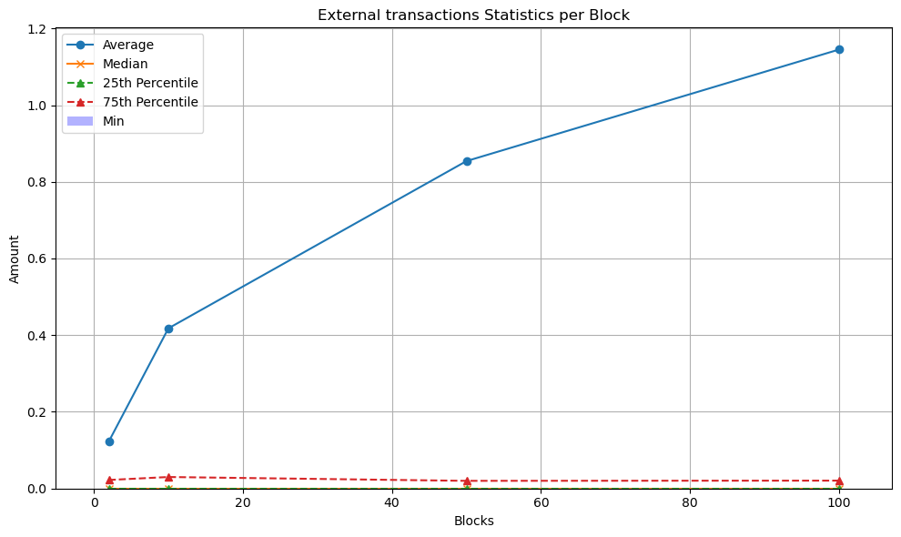
Figure 11. External transactions statistics.
The persistent minimum value of 0.000 ETH across all block ranges indicates that many external transactions involve smart contract interactions without direct ETH transfer.
4.4.2 Statistics of internal transactions.
MATCH (it:InternalTransaction)
RETURN AVG(it.amount) AS average,
MIN(it.amount) AS minimum,
MAX(it.amount) AS maximum,
percentileCont(it.amount, 0.25) AS percentile_25,
percentileCont(it.amount, 0.5) AS median,
percentileCont(it.amount, 0.75) AS percentile_75
Table 10 presents the results obtained for two blocks. The same query was also executed for datasets containing 10, 50, and 100 blocks, and the corresponding results are reported in Appendix A.
Table 10. Results of Query 4.4.2 for two blocks.
Average (ETH) | Minumum (ETH) | Maximum (ETH) | Percentile 25 | Median (ETH) | Percentile 75
0,595 | 0,000 | 50,000 | 0,013 | 0,047 | 0,110
Figure 12 presents the transaction statistics for datasets containing 2, 10, 50, and 100 blocks.
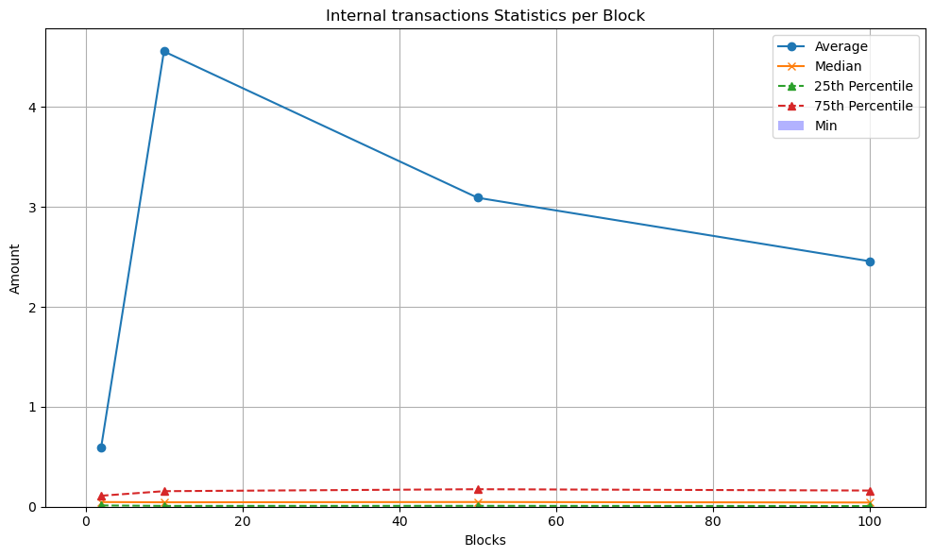
Figure 12. Internal transactions statistics.

It can be observed that the average number of internal transactions per block decreases as the number of analyzed blocks increases from 2 to 100. This suggests that a small number of unusually large internal transfers, corresponding to statistical outliers in the upper tail of the distribution, inflate the mean in smaller samples but become less influential as the sample size increases. By contrast, the median and minimum values remain low and stable across all cases, indicating that most internal transactions involve substantially smaller ETH amounts than their external counterparts. This behavior is expected because external transactions typically represent the primary "value injection" into a smart contract, whereas internal transactions often serve as the "gears" of the protocol, executing specific sub-tasks, such as distributing small fees to multiple liquidity providers, updating governance tokens, or executing partial trades. As noted by Kiffer et al. (2018), internal transactions can be viewed as "message calls" triggered by code. Since a single external transaction may generate several such calls to perform protocol-related operations, the value of each internal transfer is often only a fraction of the original external input.

5. Conclusions and future work
This work proposed a GDB model for representing Ethereum blockchain transactions. The model distinguishes between external and internal transactions, and defines nodes for accounts, blocks, and transactions, together with their corresponding relationships. Based on this model, a Neo4j GDB was constructed, and different sets of Ethereum blocks were loaded. Cypher queries were then formulated to analyze account activity, relationships between accounts, and transaction statistics.
The results suggest that behavioral patterns can be identified among highly active accounts with frequent interactions, such as the Wrapped Ether contract. In addition, certain statistical patterns, including value distributions and transaction participation percentages, tend to stabilize as the number of analyzed blocks increases. This indicates the model’s potential to discover representative behaviors from smaller block samples and to support the extrapolating of insights to larger datasets.
Future work may follow several research directions: i) extending the model with additional metadata that supports richer querying, such as block‐level fields, including base fee, miner, and validator, and transaction‐level fields, including gas used and maximum fee, ii) conducting experiments with larger block windows, since 100 blocks constitute a relatively small sample for a blockchain that produces more than one block per minute, iii) generalizing the schema to other blockchains in order to compare behavioral patterns across platforms, iv) integrating streaming and near–real-time ingestion mechanisms to support continuous analytics, v) exploring techniques for anomaly detection, including outliers and possible fraudulent behaviors, such as wash trading (Victor & Weintraud, 2021)), community discovery such as flow-based clustering of recurrent sender–receiver groups, and prediction of transaction activity in terms of fee, value, and volume, and vi) defining high-level operators to facilitate the formulation of blockchain analytical queries in a GDB, since Cypher queries may become complex to formulate and interpret.

References
- Bakkal, F., Eken, S., Savaş, N. S., & Sayar, A. (2017). Modeling and querying trajectories using Neo4j Spatial and TimeTree for carpool matching. 2017 International Conference on INnovations in Intelligent SysTems and Applications (INISTA) (pp. 219–222). https://doi.org/10.1109/INISTA.2017.8001160.
- Elayam, M. M., Ray, C., & Claramunt, C. (2022). A hierarchical graph-based model for mobility data representation and analysis. Data & Knowledge Engineering, 142, 102054. https://doi.org/10.1016/j.datak.2022.102054.
- Gómez, L. I., Kuijpers, B., & Vaisman, A. (2019). Analytical queries on semantic trajectories using graph databases. Transactions in GIS, 23(5), 948–973. https://doi.org/10.1111/tgis.12556.
- Karim, L., Boulmakoul, A., Zeitouni, K., & Lbath, A. (2021). From raw pedestrian trajectories to a semantic graph-structured model: Towards an end-to-end spatiotemporal analytics framework. Procedia Computer Science, 184, 60–67. https://doi.org/10.1016/j.procs.2021.03.018.
- Khan, W., Ahmed, E., & Shahzad, W. (2017). Predictive performance comparison analysis of Relational & NoSQL graph databases. International Journal of Advanced Computer Science and Applications, 8(5). https://doi.org/10.14569/IJACSA.2017.080564
- Lin, D., Wu, J., Yuan, Q., & Zheng, Z. (2020). Modeling and understanding Ethereum transaction records via a complex network approach. IEEE Transactions on Circuits and Systems II: Express Briefs, 67(11), 2737–2741. https://doi.org/10.1109/TCSII.2020.2968376.
- Tamilmani, K., & Stefanakis, E. (2019). Modelling and analysis of semantically enriched simplified trajectories using graph databases. ISPRS International Journal of Geo-Information (Advances in Cartography and GIScience of the ICA, Vol. 1), 20. https://doi.org/10.5194/ica-adv-1-20-2019.
- Xue, C., Zhang, T., Xu, Y., & Su, F. (2022). An ocean current-oriented graph-based model for representing Argo trajectories. Computers & Geosciences, 168, 105143. https://doi.org/10.1016/j.cageo.2022.105143.
- Estupiñán, A. (2020). Analysis of modern blockchain networks using graph databases, Technische Universität Berlin, School IV - Electrical Engineering and Computer Science Department of Telecommunication Systems, Service-centric Networking, Master’s Thesis. (DOI: 10.13140/RG.2.2.20215.14245).
- Said A, Janjua MU, Hassan S, Muzammal Z, Saleem T, Thaipisutikul T, Tuarob S, Nawaz R. 2021. Detailed analysis of Ethereum network on transaction behavior, community structure and link prediction. PeerJ Computer Science 7:e815 https://doi.org/10.7717/peerj-cs.815
- Kiffer, L., Levin, D., & Mislove, A. (2018). Analyzing Ethereum's Smart Contract Ecosystem. Proceedings of the Internet Measurement Conference 2018, 490–496.
- Victor, F. & Weintraud, A.M., 2021. "Detecting and Quantifying Wash Trading on Decentralized Cryptocurrency Exchanges," Papers 2102.07001, arXiv.org.
- Victor, F. “Address clustering heuristics for Ethereum,” Financial Cryptography and Data Security, 2019.

Appendix A
Table 1A. Query 1.1 for each set of blocks
Number of blocks | 2 |  | 10 |  | 50 |  | 100
Rank | Account | Total Received (ETH) | Account | Total Received (ETH) | Account | Total Received (ETH) | Account | Total Received (ETH)
1 | 0x10da...56ba8e | 50,000 | 0x5efc...2c8918 | 512,000 | 0x8934...c7b2b9 | 2943,000 | 0xc02a...756cc2 | 4644,100
2 | 0xc02a...756cc2 | 15,220 | 0xf2f3...5d0d60 | 512,000 | 0xc02a...756cc2 | 2107,110 | 0x8934...c7b2b9 | 3143,390
3 | 0xe37e...57bd09 | 9,600 | 0x125b...a0fda3 | 512,000 | 0x3088...daf216 | 1462,110 | 0xa9d1...1d3e43 | 2514,960
4 | 0x1111...960582 | 7,634 | 0x1111...842a65 | 472,184 | 0xe537...ed1961 | 1462,000 | 0xe37e...57bd09 | 1759,990
5 | 0x7a25...f2488d | 5,841 | 0xc86c...583d12 | 442,431 | 0x1111...842a65 | 817,616 | 0x1111...960582 | 1581,800
6 | 0x449f...a3d115 | 5,108 | 0x05e1...daf6de | 311,560 | 0xc86c...583d12 | 773,184 | 0x28c6...f21d60 | 1507,470
7 | 0x77f8...292702 | 2,970 | 0x0b2f...07c8c2 | 199,035 | 0xf2f3...5d0d60 | 512,176 | 0x3088...daf216 | 1482,290
8 | 0x3220...bf5daa | 2,804 | 0xc02a...756cc2 | 119,353 | 0x5efc...2c8918 | 512,158 | 0xe537...ed1961 | 1462,000
9 | 0x3fc9...2b7fad | 2,782 | 0x8131...8afe12 | 50,000 | 0x125b...a0fda3 | 512,000 | 0x8408...4bb486 | 1146,770
10 | 0x1111...842a65 | 2,740 | 0x045e...d37ac2 | 50,000 | 0x28c6...f21d60 | 408,223 | 0x1111...842a65 | 1022,310
Table 2A. Query 1.2 for each set of blocks
Number of blocks | 2 |  | 10 |  | 50 |  | 100
Rank | Account | Total Sent (ETH) | Account | Total Sent | Account | Total Sent | Account | Total Sent
1 | 0xc02a...756cc2 | 55,555 | 0xc02a...756cc2 | 537,448 | 0x8934...c7b2b9 | 2.943,000 | 0xc02a...756cc2 | 3.290,390
2 | 0xe37e...57bd09 | 9,600 | 0xd401...ae1513 | 512,387 | 0xc02a...756cc2 | 2.674,990 | 0x8934...c7b2b9 | 3.143,390
3 | 0x1111...960582 | 7,634 | 0xf2f3...5d0d60 | 512,000 | 0xe537...ed1961 | 1.462,000 | 0xb5d8...43f511 | 2.919,580
4 | 0x7f1d...e4219b | 7,451 | 0x125b...a0fda3 | 512,000 | 0x1111...842a65 | 817,616 | 0xe37e...57bd09 | 1.759,990
5 | 0x3a21...a74b22 | 5,108 | 0x1111...842a65 | 472,184 | 0xc86c...583d12 | 770,000 | 0x1111...960582 | 1.581,800
6 | 0x7a25...f2488d | 3,641 | 0x889e...12f9b1 | 311,560 | 0xd401...ae1513 | 513,374 | 0xe537...ed1961 | 1.462,000
7 | 0x6edf...1c5048 | 2,804 | 0x4530...92b785 | 199,718 | 0xf2f3...5d0d60 | 512,176 | 0xba15...cd78ed | 1.450,000
8 | 0x3fc9...2b7fad | 2,782 | 0x10da...56ba8e | 50,000 | 0x125b...a0fda3 | 512,000 | 0x88bb...81a098 | 1.264,790
9 | 0x1111...842a65 | 2,740 | 0x3ab4...d02c90 | 50,000 | 0x0d07...b492fe | 400,442 | 0xc735...026933 | 1.075,710
10 | 0xea22...d676f5 | 2,300 | 0xe37e...57bd09 | 39,808 | 0x3088...daf216 | 400,139 | 0x1111...842a65 | 1.022,310

Table 3A. Query 2.1 for each set of blocks
Number of blocks | 2 |  | 10 |  | 50 |  | 100
Rank | Account | Received Percentage (%) | Account | Received Percentage (%) | Account | Received Percentage (%) | Account | Received Percentage (%)
1 | 0xdac1...831ec7 | 9,813 | 0xdac1...831ec7 | 8,959 | 0xdac1...831ec7 | 8,623 | 0xdac1...831ec7 | 8,545
2 | 0xc02a...756cc2 | 8,645 | 0xc02a...756cc2 | 7,185 | 0xc02a...756cc2 | 6,729 | 0xc02a...756cc2 | 6,960
3 | 0x3fc9...2b7fad | 4,907 | 0x3fc9...2b7fad | 4,729 | 0x3fc9...2b7fad | 5,311 | 0x3fc9...2b7fad | 4,890
4 | 0x7a25...f2488d | 3,972 | 0x7a25...f2488d | 3,092 | 0x7a25...f2488d | 3,021 | 0x7a25...f2488d | 3,131
5 | 0xa0b8...06eb48 | 2,804 | 0xa0b8...06eb48 | 2,592 | 0xa0b8...06eb48 | 2,387 | 0xa0b8...06eb48 | 2,170
6 | 0x80a6...cd5d9e | 2,336 | 0x80a6...cd5d9e | 2,456 | 0x80a6...cd5d9e | 1,797 | 0x3328...309c49 | 1,956
7 | 0x1111...960582 | 2,103 | 0x51c7...502a7f | 2,092 | 0x9522...4bafe5 | 1,612 | 0x80a6...cd5d9e | 1,624
8 | 0x69a4...152cea | 1,636 | 0x1f90...76c326 | 1,637 | 0x3328...309c49 | 1,260 | 0x9522...4bafe5 | 1,594
9 | 0x3328...309c49 | 1,636 | 0xf3de...509127 | 1,319 | 0xa69b...56e78c | 1,127 | 0xa69b...56e78c | 1,214
10 | 0xa8f2...2acba4 | 1,401 | 0x1111...960582 | 1,228 | 0x51c7...502a7f | 1,066 | 0x1111...960582 | 1,100

Table 4A. Query 2.2 for each set of blocks
Number of blocks | 2 |  | 10 |  | 50 |  | 100
Rank | Account | Sent Percentage (%) | Account | Sent Percentage (%) | Account | Sent Percentage (%) | Account | Sent Percentage (%)
1 | 0xc02a...756cc2 | 7,243 | 0xc02a...756cc2 | 6,219 | 0xc02a...756cc2 | 5,931 | 0xc02a...756cc2 | 6,044
2 | 0x7a25...f2488d | 3,271 | 0x3fc9...2b7fad | 3,177 | 0x3fc9...2b7fad | 3,370 | 0x3fc9...2b7fad | 3,011
3 | 0x3fc9...2b7fad | 3,271 | 0x7a25...f2488d | 2,179 | 0x7a25...f2488d | 1,989 | 0x7a25...f2488d | 2,225
4 | 0xe37e...57bd09 | 2,336 | 0x51c7...502a7f | 1,589 | 0x80a6...cd5d9e | 1,162 | 0x3328...309c49 | 2,033
5 | 0x1111...960582 | 1,402 | 0x80a6...cd5d9e | 1,589 | 0xa9d1...1d3e43 | 1,074 | 0x80a6...cd5d9e | 1,087
6 | 0x80a6...cd5d9e | 1,402 | 0xa9d1...1d3e43 | 1,044 | 0xa69b...56e78c | 0,968 | 0xa9d1...1d3e43 | 1,087
7 | 0xdfd5...43963d | 1,168 | 0xe37e...57bd09 | 0,953 | 0x3328...309c49 | 0,950 | 0xa69b...56e78c | 0,973
8 | 0x0000...3eb395 | 1,168 | 0xf3de...509127 | 0,862 | 0xea22...d676f5 | 0,845 | 0xea22...d676f5 | 0,838
9 | 0x3328...309c49 | 1,168 | 0xea22...d676f5 | 0,817 | 0x51c7...502a7f | 0,669 | 0xe37e...57bd09 | 0,751
10 | 0x4634...eb9758 | 1,168 | 0x3a10...1a981f | 0,817 | 0xe37e...57bd09 | 0,660 | 0xf3de...509127 | 0,628

Table 5A. Query 2.3 for each set of blocks
Number of blocks | 2 |  | 10 |  | 50 |  | 100
Rank | Account | Total Percentage (%) | Account | Total Percentage (%) | Account | Total Percentage (%) | Account | Total Percentage (%)
1 | 0xc02a...756cc2 | 7,944 | 0xc02a...756cc2 | 7,192 | 0xc02a...756cc2 | 7,821 | 0xc02a...756cc2 | 8,522
2 | 0xdac1...831ec7 | 4,907 | 0xdac1...831ec7 | 4,803 | 0x3fc9...2b7fad | 5,362 | 0xdac1...831ec7 | 5,598
3 | 0x3fc9...2b7fad | 4,089 | 0x3fc9...2b7fad | 4,242 | 0xdac1...831ec7 | 5,324 | 0x3fc9...2b7fad | 5,178
4 | 0x7a25...f2488d | 3,621 | 0x7a25...f2488d | 2,828 | 0x7a25...f2488d | 3,095 | 0x7a25...f2488d | 3,510
5 | 0x80a6...cd5d9e | 1,869 | 0x80a6...cd5d9e | 2,170 | 0x80a6...cd5d9e | 1,827 | 0x3328...309c49 | 2,615
6 | 0xe37e...57bd09 | 1,869 | 0x51c7...502a7f | 1,975 | 0xa0b8...06eb48 | 1,474 | 0x80a6...cd5d9e | 1,777
7 | 0x1111...960582 | 1,752 | 0xa0b8...06eb48 | 1,390 | 0x3328...309c49 | 1,365 | 0xa69b...56e78c | 1,433
8 | 0x3328...309c49 | 1,402 | 0xf3de...509127 | 1,170 | 0xa69b...56e78c | 1,294 | 0xa0b8...06eb48 | 1,422
9 | 0xa0b8...06eb48 | 1,402 | 0x3328...309c49 | 1,024 | 0x9522...4bafe5 | 1,148 | 0x9522...4bafe5 | 1,193
10 | 0x69a4...152cea | 1,168 | 0x1111...960582 | 1,024 | 0x51c7...502a7f | 1,071 | 0x1111...960582 | 1,124

Table 6A. Query 3.1 for each set of blocks
Number of blocks | 2 |  | 10 |  | 50 |  | 100
Rank | Account | Transaction Count | Account | Transaction Count | Account | Transaction Count | Account | Transaction Count
1 | 0xf89d...5eaa40 -> 0xdac1...831ec7 | 3 | 0x5433...cd3c08 -> 0xea22...d676f5 | 9 | 0x5433...cd3c08 -> 0xea22...d676f5 | 48 | 0x5433...cd3c08 -> 0xea22...d676f5 | 96
2 | 0xdfd5...43963d -> 0xdac1...831ec7 | 2 | 0xcc3f...38e4e1 -> 0x5bf3...98a8ed | 9 | 0xb74c...e55c8d -> 0xff09...af1b1f | 45 | 0xb74c...e55c8d -> 0xff09...af1b1f | 79
3 | 0xa85b...632108 -> 0x4c67...82f802 | 2 | 0x978d...efb7e7 -> 0xa5a7...07bdb6 | 8 | 0x34ed...50058a -> 0x56d9...5199a0 | 42 | 0xc274...86f364 -> 0x163f...318753 | 63
4 | 0x5433...cd3c08 -> 0xea22...d676f5 | 2 | 0x3931...09fdd0 -> 0x4ec1...81f4c3 | 7 | 0xcc3f...38e4e1 -> 0x5bf3...98a8ed | 33 | 0x34ed...50058a -> 0x56d9...5199a0 | 57
5 | 0x2326...7a5798 -> 0x3bc1...514326 | 2 | 0xf6f7...4ec0f4 -> 0x5f97...bbe058 | 6 | 0xc274...86f364 -> 0x163f...318753 | 31 | 0xae2f...1fae13 -> 0x1f2f...6df387 | 52
6 | 0xb233...d7c460 -> 0xdac1...831ec7 | 2 | 0xb74c...e55c8d -> 0xff09...af1b1f | 6 | 0x3931...09fdd0 -> 0x4ec1...81f4c3 | 28 | 0x0000...d74a5f -> 0x68d3...3e0dc9 | 47
7 | 0xcc3f...38e4e1 -> 0x5bf3...98a8ed | 2 | 0xc274...86f364 -> 0x163f...318753 | 5 | 0x0000...3bcbe0 -> 0x68d3...3e0dc9 | 25 | 0x0000...3bcbe0 -> 0x68d3...3e0dc9 | 46
8 | 0x4481...3f5af8 -> 0x68d3...e66fbf | 2 | 0x0000...d74a5f -> 0x68d3...3e0dc9 | 5 | 0xae2f...1fae13 -> 0x1f2f...6df387 | 25 | 0x4634...eb9758 -> 0xdac1...831ec7 | 45
9 | 0x978d...efb7e7 -> 0xa5a7...07bdb6 | 2 | 0xb233...d7c460 -> 0xdac1...831ec7 | 5 | 0x0000...d74a5f -> 0x68d3...3e0dc9 | 24 | 0x89e5...aa7c40 -> 0xdac1...831ec7 | 37
10 | 0x89e5...aa7c40 -> 0xdac1...831ec7 | 2 | 0x21a3...285549 -> 0xdac1...831ec7 | 5 | 0x22b0...b17e96 -> 0x68d3...e66fbf | 22 | 0x7830...a86f43 -> 0xa9d1...1d3e43 | 35

Table 7A. Query 3.2 for each set of blocks
Number of blocks | 2 |  | 10 |  | 50 |  | 100
Rank | Account | Total Value Sent (ETH) | Account | Total Value Sent (ETH) | Account | Total Value Sent (ETH) | Account | Total Value Sent (ETH)
1 | 0x7f1d...e4219b -> 0x1111...960582 | 7,4510 | 0x4530...92b785 -> 0x0b2f...07c8c2 | 199,0350 | 0xe537...ed1961 -> 0x3088...daf216 | 1.462,0000 | 0xb5d8...43f511 -> 0xa9d1...1d3e43 | 2.505,7400
2 | 0x3a21...a74b22 -> 0x449f...a3d115 | 5,1080 | 0x3ab4...d02c90 -> 0x8131...8afe12 | 50,0000 | 0xc86c...583d12 -> 0x8934...c7b2b9 | 770,0000 | 0xe537...ed1961 -> 0x3088...daf216 | 1.462,0000
3 | 0x6edf...1c5048 -> 0x3220...bf5daa | 2,8040 | 0x10da...56ba8e -> 0x045e...d37ac2 | 50,0000 | 0x0d07...b492fe -> 0xaea6...b47a00 | 399,9980 | 0xba15...cd78ed -> 0x1111...960582 | 1.450,0000
4 | 0x5433...cd3c08 -> 0xea22...d676f5 | 2,3000 | 0xa141...ae4d56 -> 0x1111...842a65 | 24,4200 | 0x2178...48fda1 -> 0x8934...c7b2b9 | 399,0000 | 0x88bb...81a098 -> 0x8408...4bb486 | 1.146,7700
5 | 0x34e1...3b2093 -> 0x1111...842a65 | 2,0000 | 0x8a4a...ae64c1 -> 0x4408...480a80 | 20,0000 | 0x4530...92b785 -> 0x0b2f...07c8c2 | 398,1400 | 0xc735...026933 -> 0x28c6...f21d60 | 1.075,7100
6 | 0x1fa9...37b4b7 -> 0x2ea1...4b1281 | 1,4930 | 0x4976...eb2327 -> 0x1bf6...4ca7cc | 17,3110 | 0xae4b...270952 -> 0x28c6...f21d60 | 391,0000 | 0xc86c...583d12 -> 0x8934...c7b2b9 | 770,0000
7 | 0x5f0b...4bac7b -> 0x80a6...cd5d9e | 1,0000 | 0xfd80...3de4b7 -> 0x877c...ebd2eb | 15,0000 | 0x05e1...daf6de -> 0x8934...c7b2b9 | 312,0000 | 0x0d07...b492fe -> 0xaea6...b47a00 | 399,9980
8 | 0x978d...efb7e7 -> 0xa5a7...07bdb6 | 0,9670 | 0x4162...06eef5 -> 0x4537...9081d1 | 14,3470 | 0xe615...0354f1 -> 0xbf94...bb420b | 167,4530 | 0x2178...48fda1 -> 0x8934...c7b2b9 | 399,0000
9 | 0x1a2d...691f13 -> 0x3fc9...2b7fad | 0,6600 | 0x6edf...1c5048 -> 0x7ff4...5e4c76 | 12,8950 | 0xad6e...ed8862 -> 0xf551...097915 | 164,7080 | 0x4530...92b785 -> 0x0b2f...07c8c2 | 398,1400
10 | 0xf855...288101 -> 0x3fc9...2b7fad | 0,6140 | 0x7dc5...a0098b -> 0xb3e8...35bc88 | 11,2490 | 0xef74...b0a381 -> 0xbf94...bb420b | 125,1440 | 0xae4b...270952 -> 0x28c6...f21d60 | 391,0000

Table 8A. Query 4.1 for each set of blocks
Number of blocks | Average Value (ETH) | Minumum Value (ETH) | Maximum Value (ETH) | Percentile 25 | Median Value | Percentile 75
2 | 0,123 | 0 | 7.451 | 0 | 0 | 0.022
10 | 0.418 | 0 | 199.035 | 0 | 0 | 0.03
50 | 0.854 | 0 | 1462 | 0 | 0 | 0.02
100 | 1.145 | 0 | 2505.74 | 0 | 0 | 0.021

Table 9A. Query 4.2 for each set of blocks
Number of blocks | Average Value (ETH) | Minumum Value (ETH) | Maximum Value (ETH) | Percentile 25 | Median Value | Percentile 75
2 | 0,595 | 0,000 | 50,000 | 0,013 | 0,047 | 0,110
10 | 4,558 | 0,000 | 512,000 | 0,008 | 0,044 | 0,155
50 | 3,093 | 0,000 | 1462,000 | 0,009 | 0,047 | 0,175
100 | 2,457 | 0,000 | 1462,000 | 0,007 | 0,042 | 0,162

Oracle also supports non-relational models, including GDBs. Graph-related functionality has been available since Oracle 12c, while Oracle 23ai introduces native SQL support for graph creation and querying.

